1.Client:

<https://www.drivedigitally.com/hwfinal/task-details/S3U3ZLMW89>

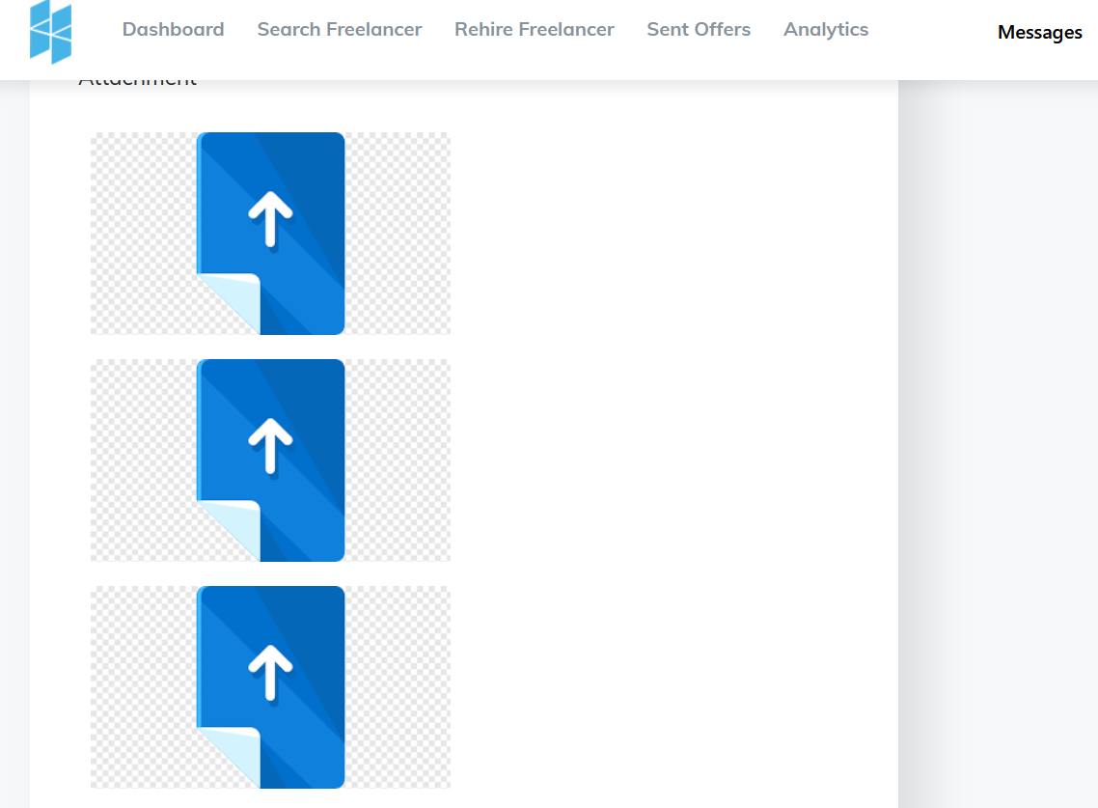

Why the attachment come this way ? in back up this way not came ?

Please, fix it , as Doc name like .xls, .doc, .jpeg .

1. Freelancer :

<https://www.drivedigitally.com/hwfinal/job-details/S3U3ZLMW89>

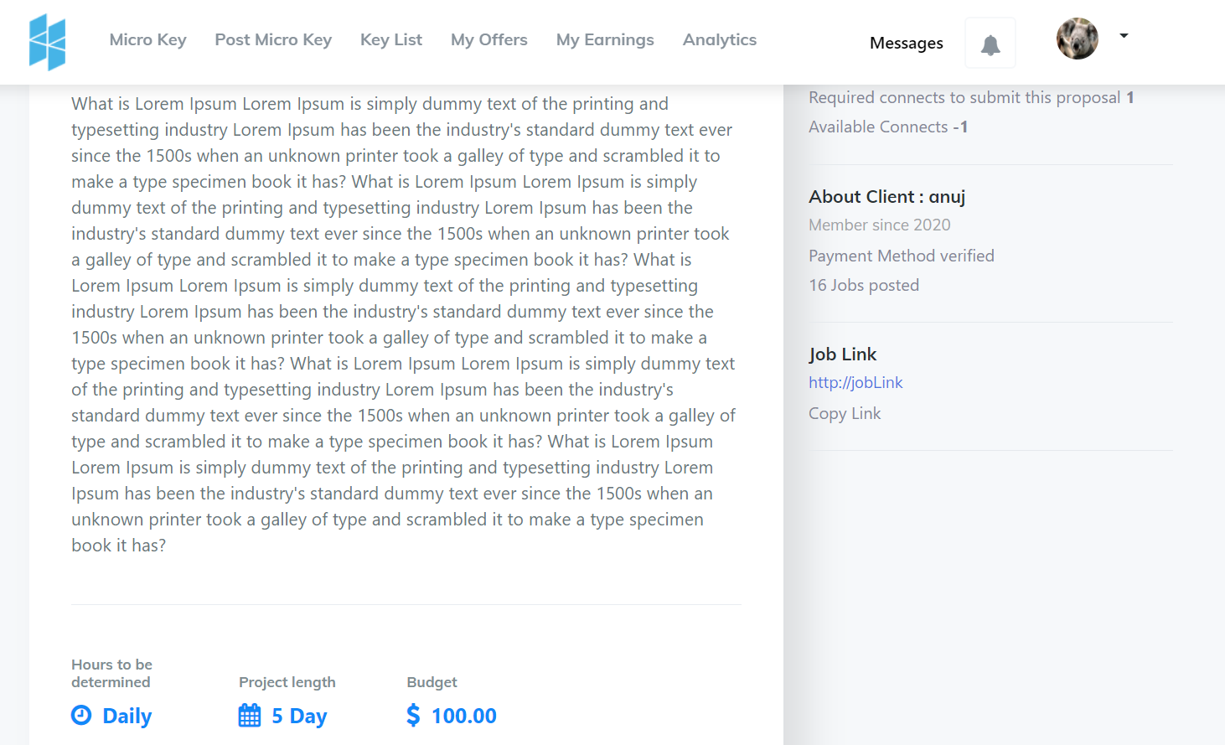

Why the freelancer cant see the attachment done by client ? in back up this way not came ?

Please, fix it , as Doc name like .xls, .doc, .jpeg .

1. Client :

<https://www.drivedigitally.com/hwfinal/view-all-offers/VUZ1SA13YP>

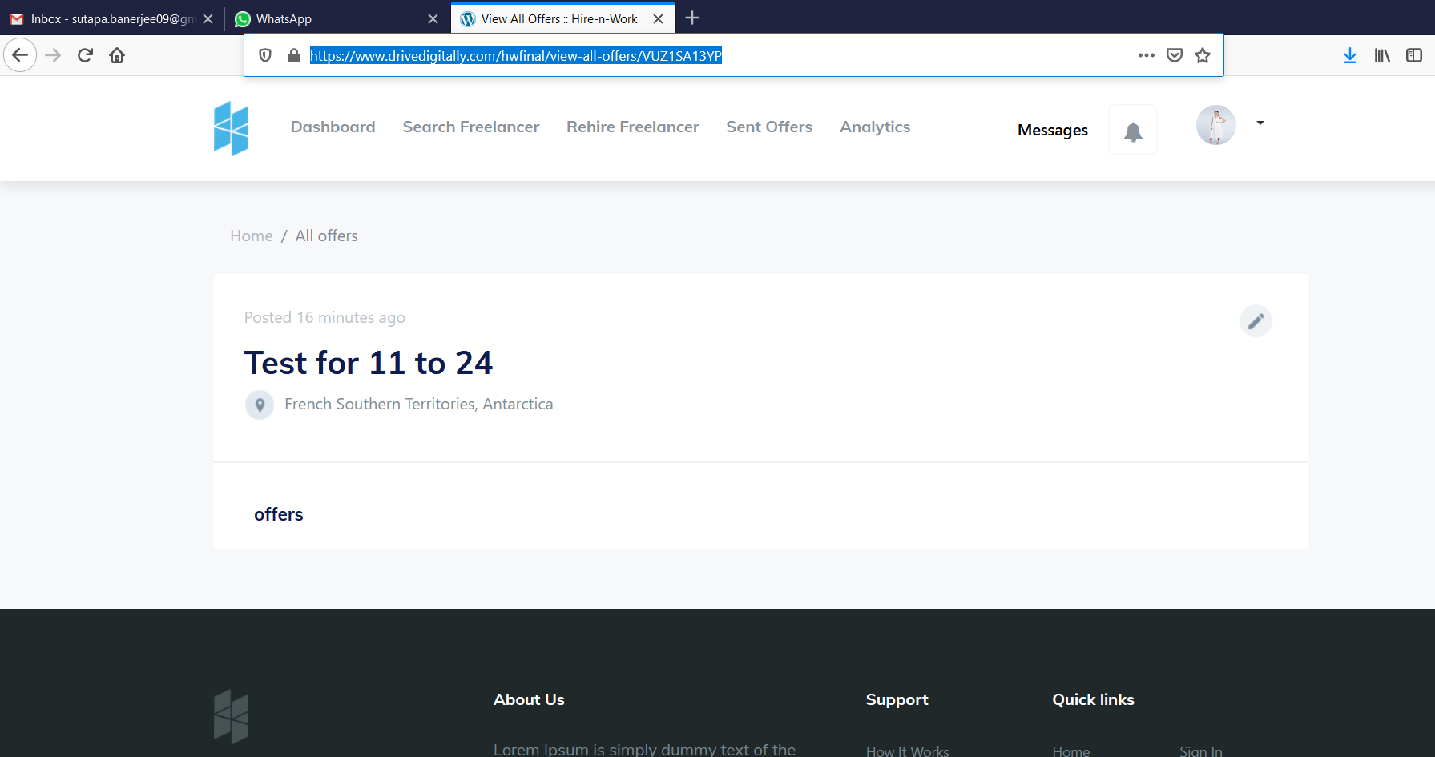

Make a list here who have already offered for this project .

1. Client + freelancer message

Attachment can not be done , so fix it , it also run in my back up.

5. Client

Hire date calculation will start at the time when client hire the freelancer. Once this date cross then it will count late. So client site need to add a calendar from where the hire date will count while hiring.

6. Freelancer

1. Freelancer got offer goes to > NEW,

2. Freelancer got hired goes to > ACTIVE

3. Freelancer crossed late date the project shows LATE

4. Client accepted work of freelancer those project goes to DELIVERED

5. **FREELANCER COMPLETED WORK GOES TO COMPLETED**

1. 6. Which project r cancel, those goes to CANCELLED

7. Freelancer analytics still not done .

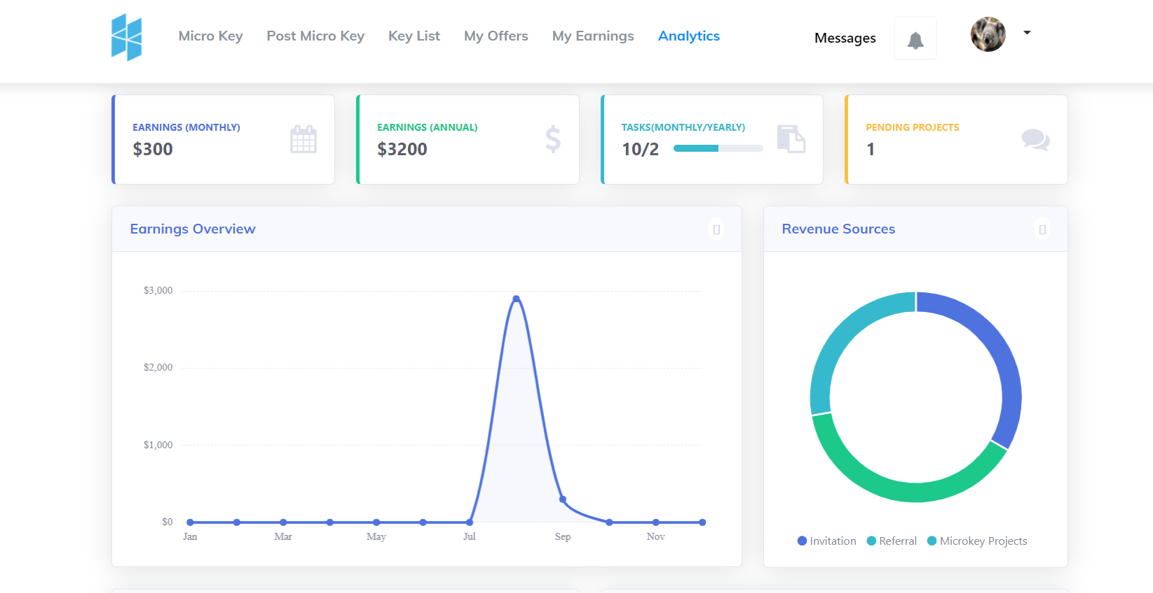

An extra point r running in my back up.

<https://www.drivedigitally.com/hwfinal/Freelancer/see_all_projects>

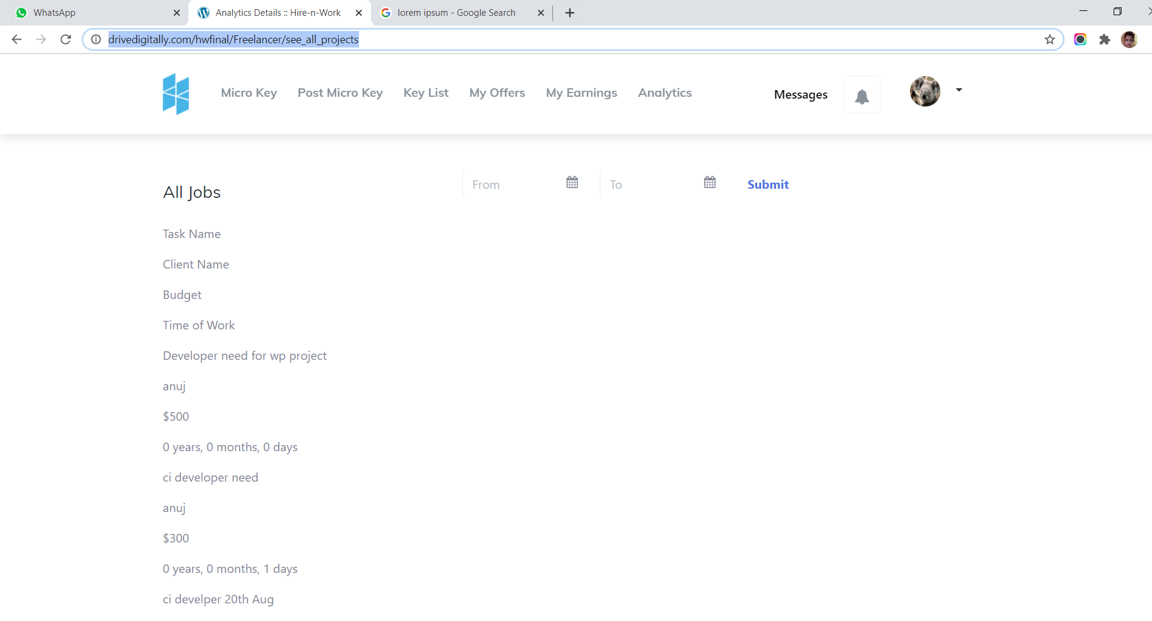

Why this is coming in freelancer analytics

8. Client analytics still not done.

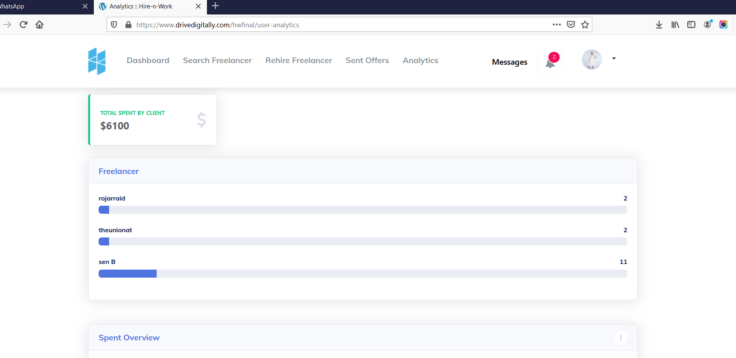

Remove this part.

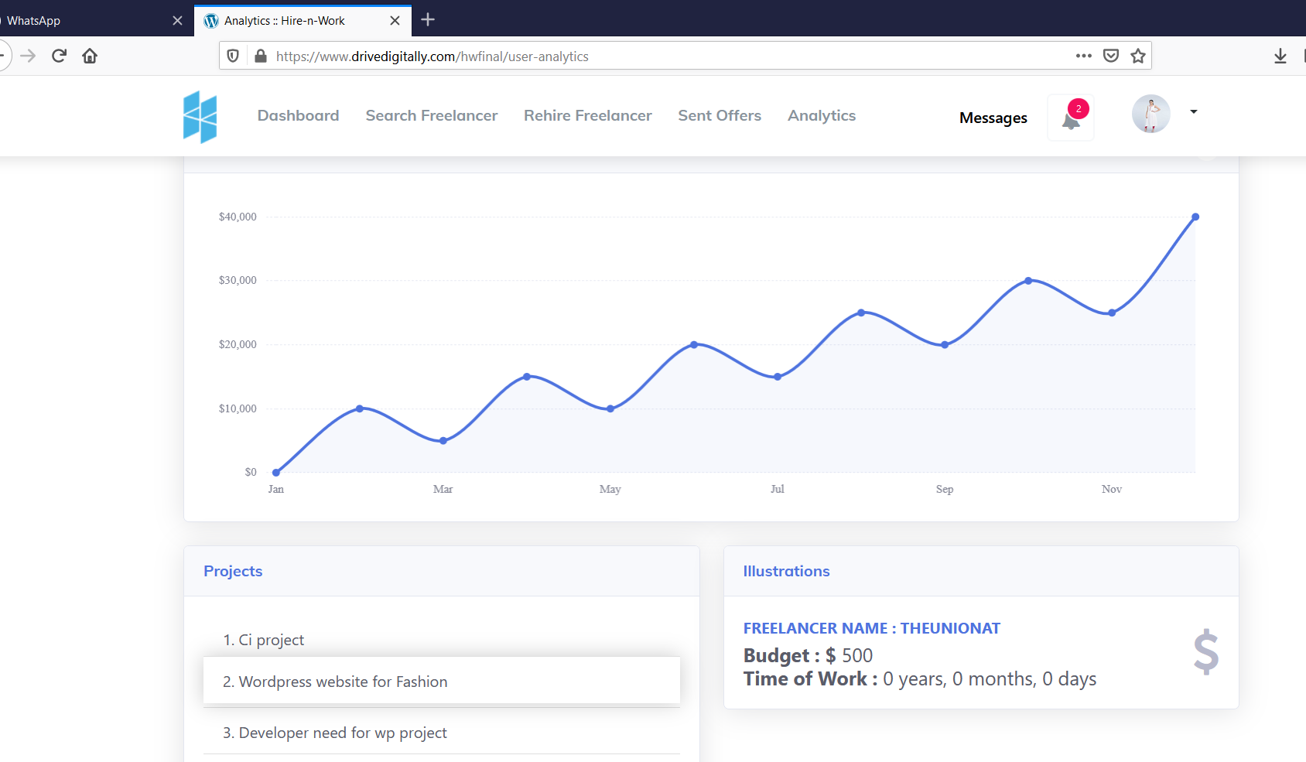

Need to put here spend analytics .which is already in design .

Calender noting is wrong